Electric Current W.S.
Water doesn't flow in the pipe when (a) both ends are at the same level. Another way of saying this is that water will not flow in the pipe when both ends have the same potential energy (PE).
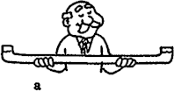

Similarly, charge will not flow in a conductor if both ends of the conductor are at the same electric potential.

But tip the water pipe and increase the PE of one side so there is a difference in PE across the ends of the pipe, as in (b), and water will flow.
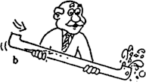

Similarly, increase the electric potential of one end of an electric conductor so there is a potential difference across the ends, and charge will flow.

- The units of electric potential difference are
.

volts | amperes | ohms | watts

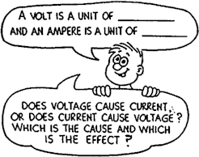
- It is common to call electric potential difference .

voltage | amperage | wattage

- The flow of electric charge is called electric
.

voltage | current | power

- The flow of electric charge is measured in
.

volts | amperes | ohms | watts

Refer to the following information for the next six questions.

Complete these statements:

- A current of 2 ampere is a flow of charge at the rate of coulomb per second.

- When a charge of l0 C flows through any area in a circuit each second, the current is A

- One volt is the potential difference between two points if 1 joule of energy is needed to move
coulomb of charge between the two points.

- When a lamp is plugged into a 120-V socket, each coulomb of charge that flows in the circuit is raised to a potential energy of joules.

- Which offers more resistance to water flow?

a wide pipe | a narrow pipe

- Similarly, which offers more resistance to the flow of charge?

a thick wire | a thin wire
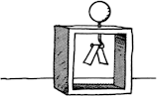
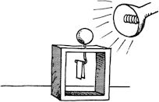

- REVIEW: When the zinc ball of the charged electroscope is illuminated with ultraviolet light, the leaves of the electroscope collapse. Was the electroscope charged positive or negative?
- Which is more dangerous, touching a faulty 110-volt light bulb or a Van de Graaff generator charged to 100,000 volts? Why?
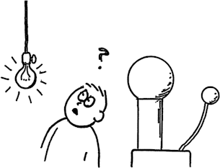

REVIEW: It has been observed that if a cow takes shelter under a tree in an electrical storm, then it is more likely to be killed if it is standard along a radius to the tree than if it was standing sideways on to the tree. Why is this? (Consider the tree to be at a potential of 1 000 000 V after the strike. Draw in a set of equipotentials round the tree trunk. The put in a cow in the radial direction and a cow in the sideways direction).

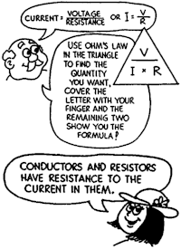
- How much current flows in a 1000-ohm resistor when 1.5 volts are impressed across it?

- If the filament resistance in an automobile headlamp is 3 ohms, how many amps does it draw when connected to a 12-volt battery?

- The resistance of the side lights on an automobile are 10 ohms. How much current flows in them when connected to 12 volts?

17. What is the current in the 30-ohm heating coil of a coffee maker that operates on a 120-volt circuit?
18. What is the resistance of a clothes iron that draws a current of 12 A at 120 V?

- What is the voltage across a 100-ohm circuit element that draws a current of 1 A?

- What voltage will produce 3 A through a 15-ohm resistor?

- The current in an incandescent lamp is 0.5 A when connected to a 120-V circuit, and 0.2 A when connected to a 10-V source. Does the resistance of the lamp change in these cases? Explain your answer and defend it with numerical values.
Refer to the following information for the next three questions.

22. During a lie detector test, a voltage of 6 V is impressed across two fingers. When a certain question is asked, the resistance between the fingers drops from 400 000 ohms to 200 000 ohms.
- What is the current initially through the fingers?

- What is the current when the resistance between them drops?

c. How much resistance would allow an impressed voltage of 6 V to produce a current of 0.006 A?
Does it take a lot of water to light a light bulb?

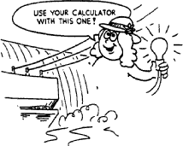

That depends on its wattage and how long it glows.

Refer to the following information for the next five questions.

23. In this practice page, you are to calculate the mass and volume of water that falls over a 10-rn high dam to keep a 100-W light bulb glowing for 1 year.
- First, calculate how many joules are required to keep the bulb lit for 1 year.

Energy = J

- What mass of water elevated 10 m has this much PE?
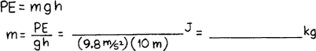

But this assumes 100% efficiency. A hydroelectric plant is typically 20% efficient. This means only 1 part in 5 of the PE of the falling water ends up as electricity. So the mass above must be multiplied by 5 to get the actual amount of water that must fall to keep the 100-W bulb lit.

- This is an impressive number of kilograms! To visualize this amount of water, convert it to cubic meters.

- For comparison, an Olympic-size swimming pool holds about 4000 m3 of water. How many such "poolfuls" of water are required to keep a 100-W bulb lit for one year?

- Does it take a lot of water to light a light bulb? To light a city full of light bulbs? Now you have a better idea!

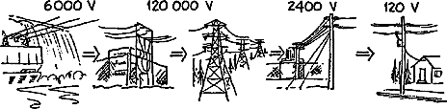

Many power companies provide power to cities that are far from the generators.
Refer to the following information for the next question.

24. Consider a city of 100,000 persons who each use continually use 120 W of power (equivalent to the operation of two 60-W light bulbs per person). The power constantly consumed is

100,000 persons x 120 W/person = 12 million W (12 MW).

a. What current corresponds to this amount of power at the common 120 V used by consumers?
Refer to the following information for the next question.

25. This is an enormous current, more than can be carried in the thickest of wires without overheating. More power would be dissipated in the form of heat than would reach the faraway city. Fortunately the important quantity is IV and not I alone. Power companies transmit power over long distances at very high voltages so that the current in the wires is low and heating of the power lines is minimized.

a. If the 12 MW of power is transmitted at 120,000 V, the current in the wires is .
Refer to the following information for the next three questions.

26. This amount of current can be carried in long-distance power lines with only small power losses due to heating (normally less than 1%). But the corresponding high voltages wired to houses would be very dangerous. So step-down transformers are used in the city.
- What ratio of primary turns to secondary turns should be on a transformer to step 120,000 V down to 2400 V?

- What ratio of primary turns to secondary turns should be on a transformer to step 2400 V down to 120 V used in household circuits?

- What is the main benefit of ac compared to dc power?

- Which of the following statements describes an electric generator?

A. A magnet is rotated through a coil of wire to produce an electric current.
B. Electric potential in a rotating coil of wire creates a permanent magnet.
C. An electrical current causes a coil of wire to rotate in a magnetic field.
D. Forces from a permanent magnet allow a coil of wire to rotate.

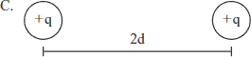
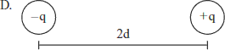
- REVIEW: Electrostatic air cleaners installed in hospitals use static electricity to reduce dust particles in the air. The neutral dust particles are attracted to positively charged ions sprayed into the air cleaners.
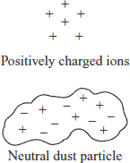

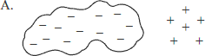
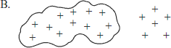
Which of the following figures shows the charge distribution on the dust particle as it is attracted to the positively charged ions?

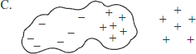
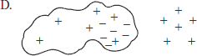
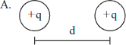
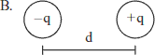
- Which of the following placements of two charges results in the greatest repulsive force?

